Mission  To promote friendship, camaraderie, education, and goodwill among persons from the Shenandoah Valley with interest in the many aspects of athletic competition  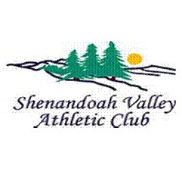 |  |  |  |  | Mailing Address:  P.O. Box 738  Harrisonburg, VA 22803  Website:  www.shenvalleysports.org  Facebook:  Meeting Location:  Rocktown Terrace,  2061F Evelyn Byrd Avenue,  Harrisonburg, VA |  |  |  |  |  |  | Sharing a common interest in scholastic, intercollegiate and  professional athletics  - Founded May 2002  www.shenvalleysports.org
Organization  The work of the club is carried out by a President, Vice President, Secretary and Treasurer as well as a board of directors. Members serve on other committees focusing on different aspects of the club.  Meetings  The club meets monthly, August-May except December. The format generally includes a social hour with cash bar, buffet dinner and program featuring a guest speaker(s).  Membership  Annual membership dues are set by the board of directors and payable before or at the first meeting. Members are encouraged to bring guests as potential members. |  |  |  |  |  | Fellowship  Food  Education |  |  |  |  | Dinner Costs  Dinner cost for members and guests is established each year. Reservations may be made online or on the form emailed prior to the meeting. Members paying at the door as well as guests pay an additional $2.  Sponsorships  The club seeks sponsorships from local individuals and businesses for each of our programs. Sponsorships help cover the cost of our programs.  Raffle  The club holds a 50/50 raffle at each meeting for financial support. Many guest speakers donate gift items/gear for the raffle.

